**Project Design Brief – Minidrone**

**SEJ302 Control Systems Engineering 2023**

**Team Members of Team 24**

Spencer De Hoedt (220392607)

Josh McNair (214119979)

Chengxin Liu (219339245)

Itai Manyanga (220115158)

Xiaoming Zhang (221527432)

Ashok Mathavan (221042401)

**Table of Contents**

Design Goal 4

Background Research 4

**Main structural elements of drones** 5

Requirements 6

The Choice of Drone 7

**Controller Overview** 9

**Torques and forces** 9

**Translational directions** 10

Process Flow Diagram 11

**Rotations** 20

**Vision-Based Path Following Algorithm** 21

Control and Manipulated Variables 22

**Controlled Variables:** 22

**Manipulated Variables:** 22

Constraints and Considerations: 23

**Regulations and Legal considerations** 23

**Project/Team constraints and considerations** 23

System modelling 24

Key Elements 24

Derivation 24

Final Equation 25

Team Charter 26

References 27

Appendix 28

# 

# Design Goal

The project aims to promote collaborative teamwork among students in designing an autonomous flight system for a parrot mini drone. Using advanced model-based design techniques, the system will detect and follow a lined path on the floor autonomously. It involves developing a sophisticated algorithm to process real-time visual information from onboard cameras and convert it into precise position data. This data will be used in a robust control algorithm to manage the drone's motor systems, ensuring stable flight and accurate path following.

# Background Research

The use of drones is now commonplace in the industrial sector with uses such as;

* Aerial photography and inspections,
* Delivery of parcels during disasters such as during COVID 19 pandemic period,
* In agriculture where farmers can monitor their crops,
* Entertainment industry,
* Used in disaster management and rescue missions,
* Geographical mapping in inaccessible locations,
* Wildlife monitoring and conservation programs e.g., poaching mitigating strategies,
* Law enforcement and border protection surveillance,
* Storm tracking in harsh weather prone areas e.g., Tornados.

Drones have revolutionized military operations, enabling surveillance, air strikes, and spying. Security agencies use miniature drones as target decoys, and they have played crucial roles in combat missions. The drone industry is rapidly growing and projected to reach over $500 billion by 2030, becoming a significant source of employment opportunities for drone enthusiasts.

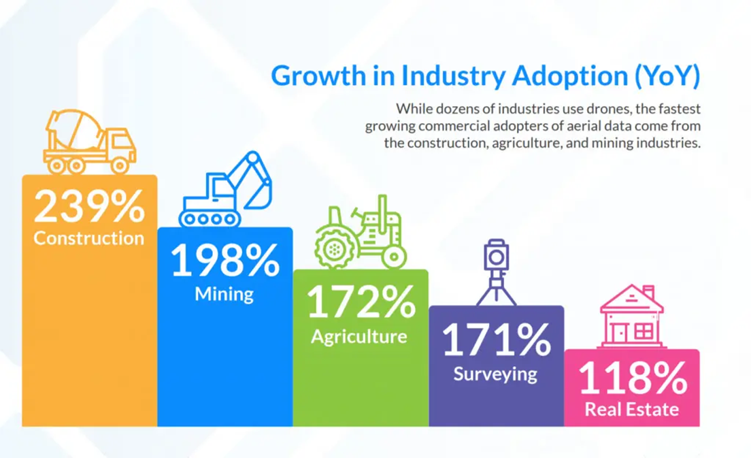

Figure 1 -Adopted from aonic.com/my/blogs-drone-technology

### **Main structural elements of drones**

Drones have two basic functions flight mode and navigation. The frame, which is where all components are mounted needs to be lightweight. The components mounted on the drone consist of;

Each of these drones have some advantages and disadvantages.

* Propellers: These are the rotor or blades which come in different shapes and sizes. They are made from lightweight materials like plastic.
* Motors: The motors are used to drive the propellers and provide thrust for flight.
* Battery: The battery supplies the power for the drone, and these are mostly rechargeable.
* Flight control cards: Are the brains of the drone which provide the controls from various parts.
* Camera: These are used to capture images and detect differences in the target area by using sensors sensitive to certain wavelengths along the electromagnetic spectrum.
* Drone controller and receiver: The controller manage and direct the drone and the receiver receive signals from the external sources and transmit to the flight controller.
* Electronic speed controller: this controller controls the speed of the electronic motors.
* Power distribution board: This distributes power to other components that need power to function such as camera, lights, flight controller etc.

## Requirements

* Start drone autonomously from a starting point
* Generate minimum thrust to flight
* Drone lifts to designated altitude
* Thrust force to move the whole system using four motors
* Orients autonomously
* Yaw moment (turn left or right)
* Identifies travel path
* Colour tracking (thresholding)
* Edge detection
* Path planning algorithm
* Track the path / image scanning / image processing system
* Hovering/Forward
* Drone hovers at a certain height (1 meter off the ground) and maintains altitude
* Stays for few seconds to orient itself
* Drone can move when red path is detected
* General steerer
* Fine steerer
* Speed selector
* Identifying turns
* Drone can turn desired orientation when the red colour is detected
* Ignore other colours
* Drone can move forward when it adjusts its position and required turn is complete
* Landing
* Drone stops and hovers when the red path is no longer detected
* Drone lands when the red circle pad is detected
* Drone turns off
* Stabilise and maintain its own weight
* Roll moment to keep the drone in horizontal position
* Pitch moment to keep the drone in horizontal position from other side view
* Lands on landing position
* Activate landing command
* Drone turn off
* Turn off the system

## 

## The Choice of Drone

The drone chosen for project completion is the Parrot Mambo Fly Minidrone, seen depicted in figures-2 and 2b.

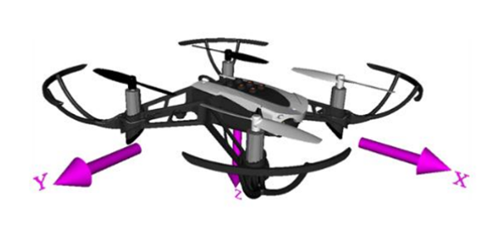

Figure 2 - Parrot Mambo Fly Minidrone

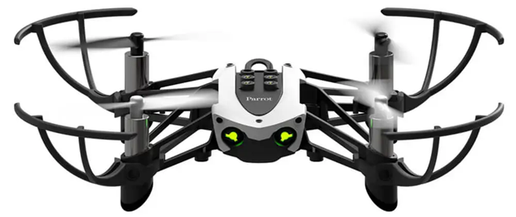

Figure 3 - Parrot Mambo Fly Minidrone

**Parrot Mambo technical specifications**

Table 1 - Drone specs

|  |  |
| --- | --- |
| Parameters Value | |
| Size | 18x18x6 cm |
| Weight | 63 g |
| Autonomy | 8 min |
| Max horizontal speed | 8 m/s |
| Max vertical speed | 2 m/s |
| Max tilt | 25 deg |
| Battery | 550 mAh LiPo type |
| Charging time | 30 min with 2.1A charger |
| Camera | 60 FPS |

The Parrot Mambo Fly minidrone has four sensors: Ultrasound, Pressure, IMU, and Camera. Unfortunately, the manufacturers have not disclosed dynamic models, thus the model provided in the Matlab "minidrone competition" project will be used. The drone is dynamically unstable, but the team plans to use virtual inputs for positioning. It features an onboard autopilot that controls motion in three axes and platform heading orientation (yaw angle). The closed-loop system ensures stability during real-time autonomous flights.

Using Matlab/Simulink we will design the controller for the drone using dynamic equations. The base Simulink model we will be altering can be seen below in figure-3

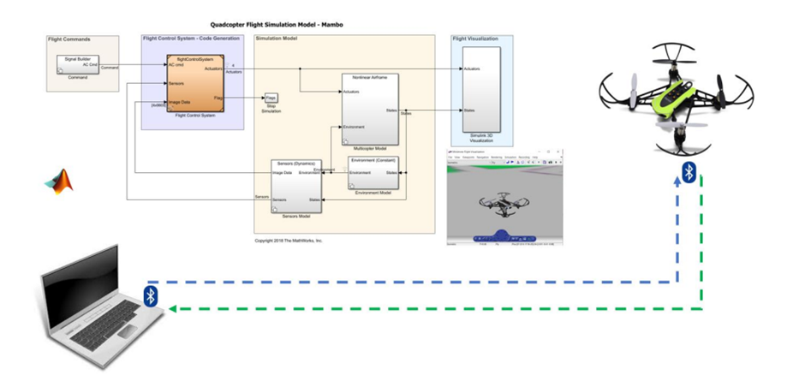

Figure 4 - The Flight simulation set up for the drone

The ultrasound sensor under the drone measures its distance from the ground. The down-facing camera estimates motion using optical flow, aiding in horizontal stabilization and speed calculation. This camera also helps with vertical stabilization and altitude estimation. The IMU sensor combines a 3-axis accelerometer and a 3-axis gyroscope, providing data on acceleration, angular rate, obstacle contact, orientation, heading, and drone acceleration [3]. - proposed change

### 

### **Controller Overview**

Figure-5 depicts a basic control structure for the Parrot Mambo Fly [4]. The fly controller receives the differences between the desired set point and the current system state as input. The sensors model block provides feedback, and the flight control system block acts as the controller. See Figure-6 for more details.

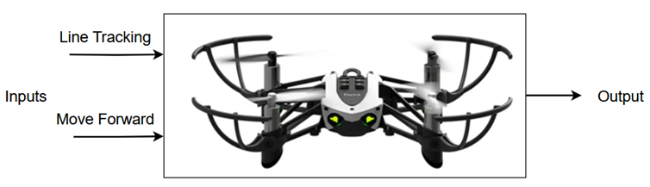

Figure 5 - Control structure

Four rotors directly control the drone's direction and altitude in 3D space. The algorithm uses the drone's updated position and orientation as inputs to act on each rotor, resulting in movement. Sensors provide system state observation.

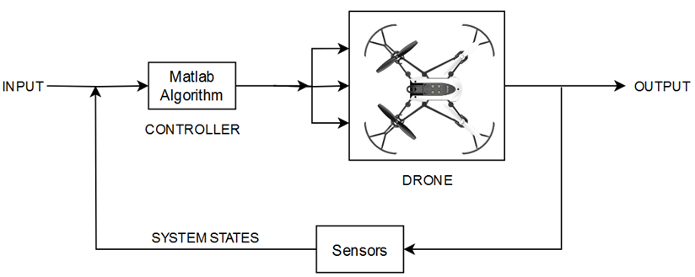

Figure 6 - flight control

### **Torques and forces**

Two motors rotate clockwise, and the other two rotate counterclockwise, producing thrust for vertical movement. When the rotors spin fast, the drone lifts into the sky; slowing down makes it descend. Rotating propellers also generate opposing torque, counteracting each other to keep the drone steady. Controlling rotor speeds achieves various directions—translational and rotational. See Figure-7 for rotations and torques of the propellers.

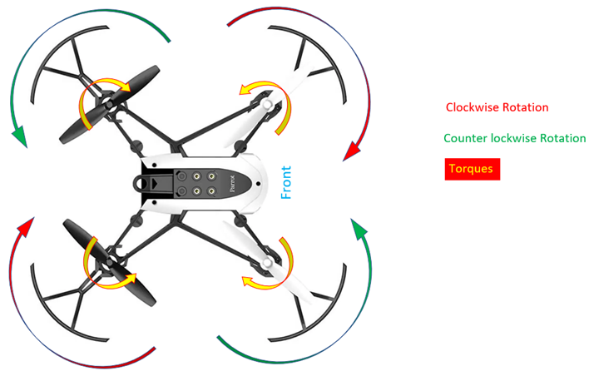

Figure 7 - torque and rotation

### **Translational directions**

The up and down movement depends on the thrust of the four motors at the same time. If the total thrust of 4 rotors is greater than the weight of the drone, drone will go up. Refer Figure-8.

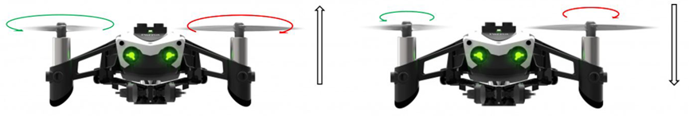

Figure 8

# Process Flow Diagram

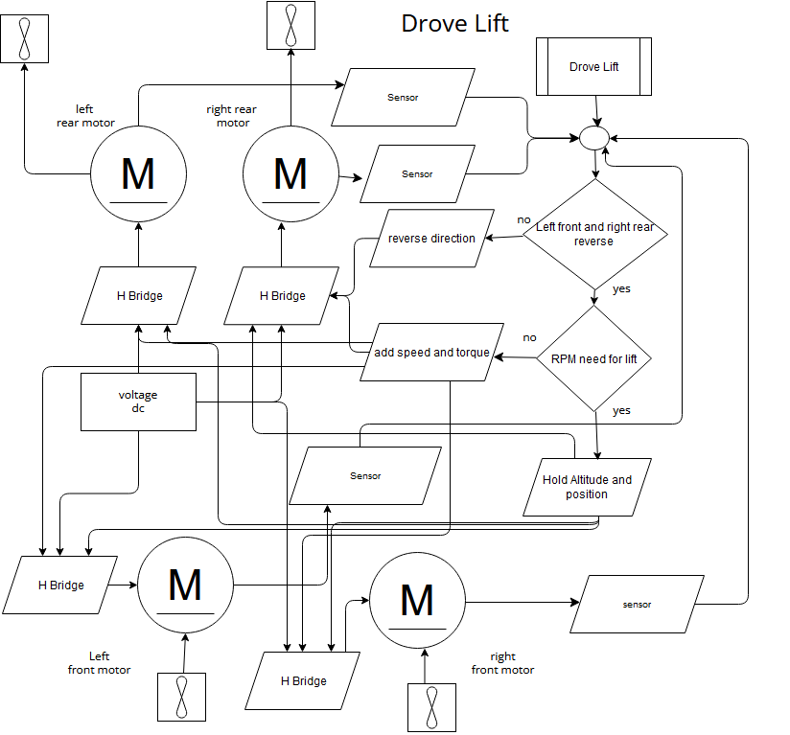

Figure 9 - Drone Lift

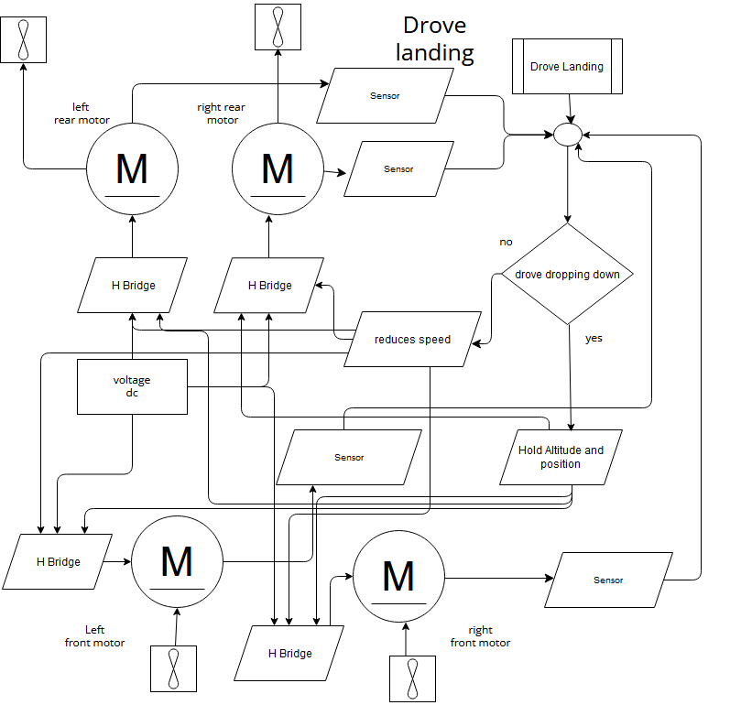

Figure 10 - Drone Landing

The left and right movements depend on the independent rotational speed between the two motors on the right and the two motors on the left. If the rotational speed of the motors on the right is higher, the quadcopter will go to the left. Refer Figure-11.

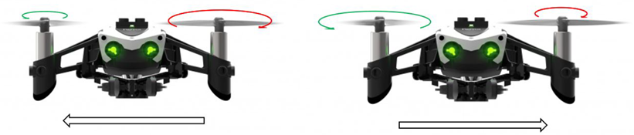

Figure 11 - Directional movement

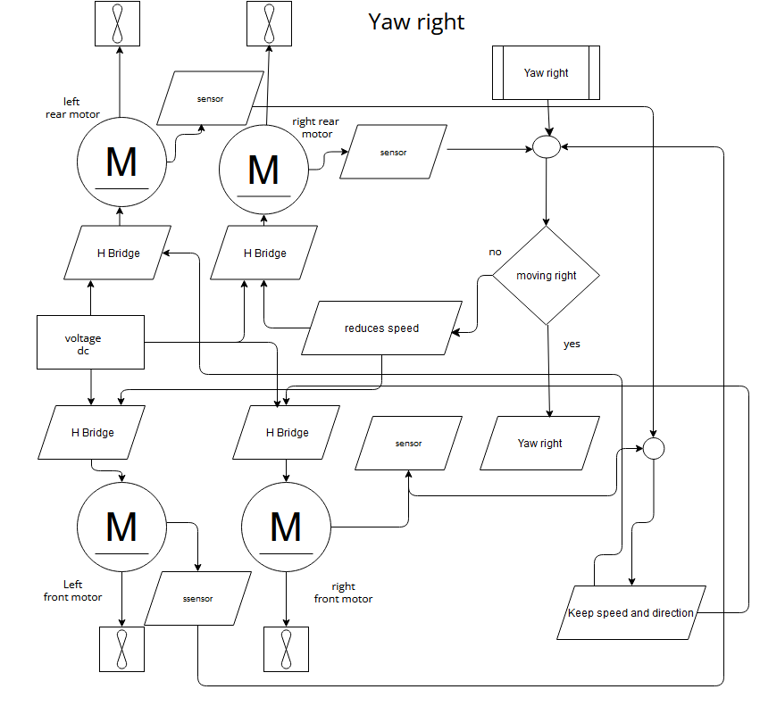

Figure 12 - Yaw Right

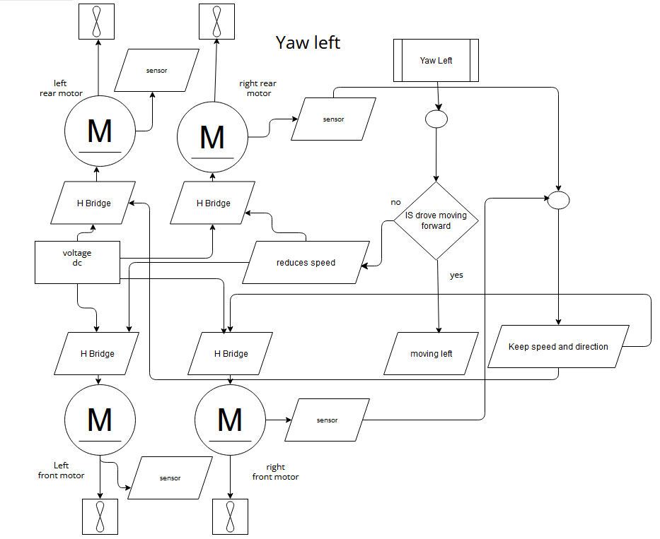

Figure 13 - Yaw Left

If the two motors in front rotate faster than the two motors in the back, the quadcopter will go backward. The size of circles indicates how large are the moments that generated from the rotors. Figure-14 shows how forward and backward moment works.

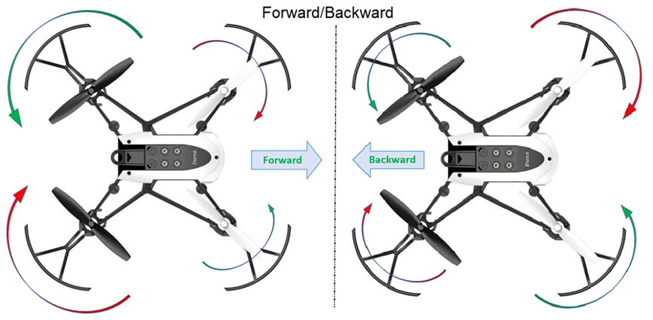

Figure 14 - Forward/Backward movement

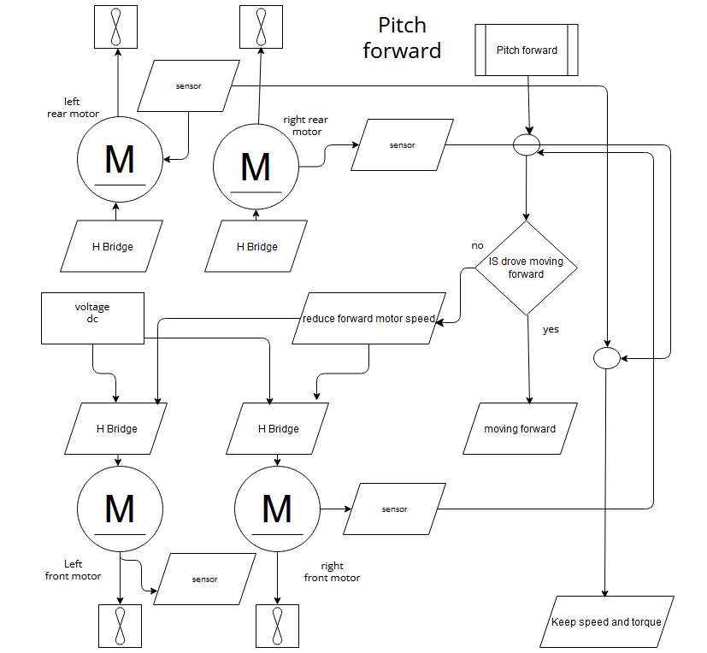

Figure 15 - Pitch Forward

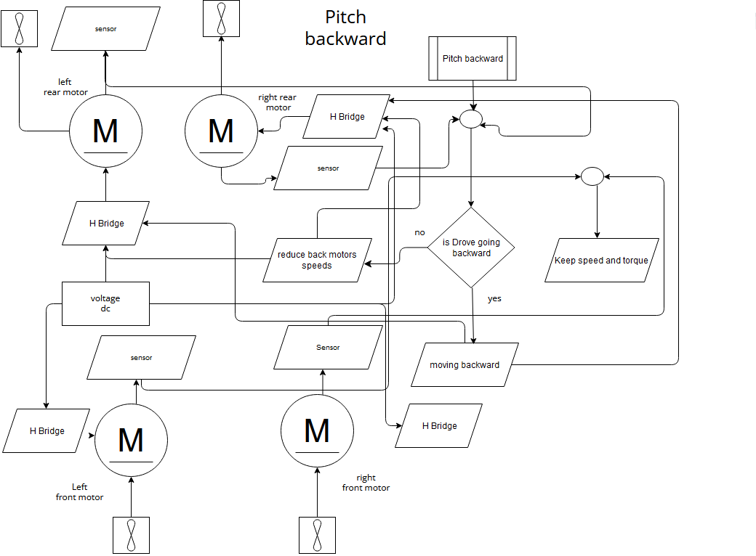

Figure 16 - Pitch Backward

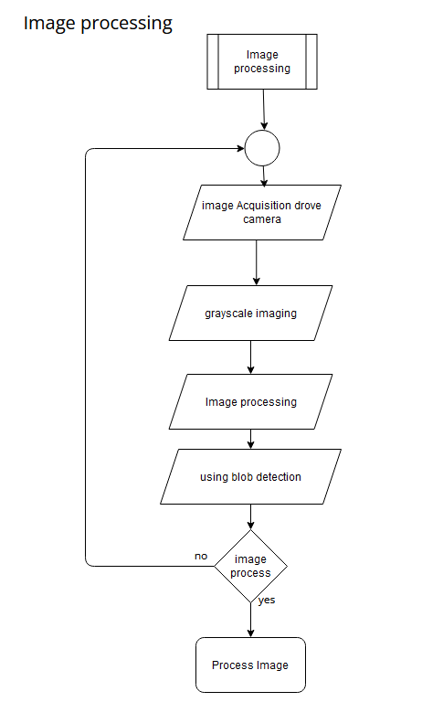

Figure 17 - Image Processing

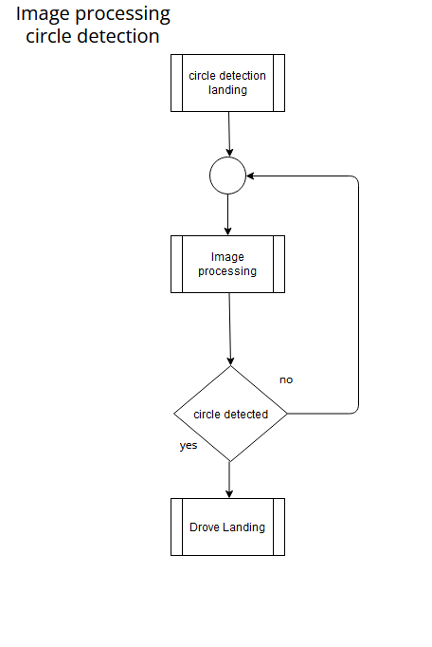

Figure 18 - Circle Detection



Figure 19 - Line Detection

### **Rotations**

The roll movement works the same way as the left and right movements. But the roll movement refers to rotating the quadcopter's motors clockwise, with respect to each rotor. Refer below Figure-20.

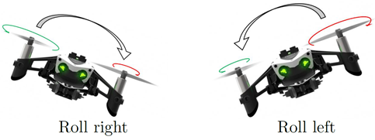

Figure 20 - Roll

The pitch movements work the same way as the roll movement but viewed from the side of the quadcopter. Thus, the pitch movement will occur when the two front, in Figure-21(left), or rear motors, in Figure-8 (right), create more thrust than the other two rotors.

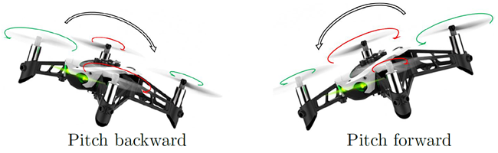

Figure 21 - Pitch

The yaw movement will occur when two rotors that spin in the same direction

make more torque than the other two rotors that spin in the opposite direction, as

shown in Figure-22.

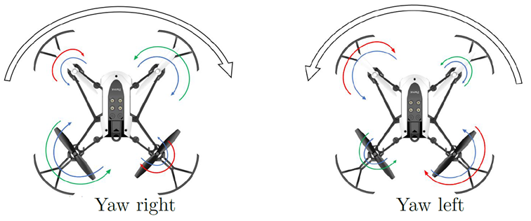

Figure 22 - Yaw

### **Vision-Based Path Following Algorithm**

The vision-based path following algorithm combines the advantages offered by the pure pursuit algorithm [6] with that of an easy image processing system to cope with the task. The algorithm starts selecting a target position ahead of the vehicle and that must be reached, typically on a path. This process is seen in figure-23.

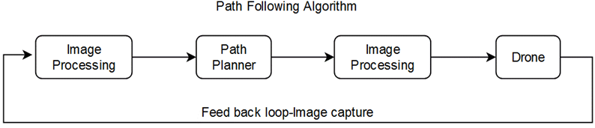

Figure 23 - Path Algorithm

Figure-13 shows control system of a path following drone. From left to right: the image processing, path planner, controller, and drone blocks. Moreover, Simulink supports Parrot Mambo drones. Toolbox in Simulink allows to build and deploy the drone control algorithms on Parrot Mambo. This program provides a simulation model that considers the airframe, a fight visualization, the fight commands, and a fight control system. The Image Processing System and the Path Planning block must be designed and implemented inside the Flight Control System.

Utilising Simulink's "parrot minidrone competition" model to build and deploy the drone control algorithms. This simulation model contains the airframe, fight visualization, fight commands, and a fight control system. The Image Processing System, Path Planning block and the Flight Control block will be altered to meet our design goal needs.

**Path planning**

The Path Planning block takes the inputs (Left, Right, Curve, Up, and Circle detection) from the colour tracking block, the estimated state values, and the reference commands. The calculated outputs are the updated commands the drone's position and orientation completed by the chart block. The inputs from the image processing block and estimated yaw than update the drone's orientation and position.

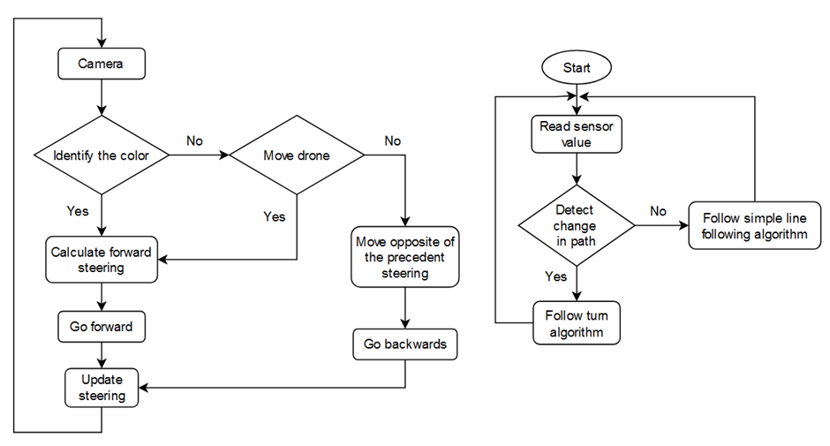

Figure 24

# Control and Manipulated Variables

### **Controlled Variables:**

* **Altitude:** The UAV's height above ground level, which needs to be controlled during flight to maintain a desired altitude.
* **Throttle**: The amount of power provided to the drone's motors, which determines the vertical lift and altitude.
* **Pitch Angle:** The angle at which the UAV's nose is pointing up or down with respect to the horizontal plane.
* **Rotation Angle:** The angle at which the UAV is rotating around its longitudinal/vertical axis.
* **Yaw**: The rotation of the drone around its vertical axis, controlling its heading or direction.
* **Velocity**: The desired speed at which the drone should move along the designated path.
* **Position:** The UAV's position relative to a reference point. (X, Y, Z)
* **Orientation:** The UAV's overall orientation in 3D space, including pitch, roll, and yaw angles.
* **Flight Mode**: The mode in which the drone operates, such as manual control, autonomous navigation, or follow-me mode.

### **Manipulated Variables:**

* **Propulsion Subsystem:** The system control input adjusts the UAV's propulsion system to control the thrust and, the altitude and speed.
* **Power system:** The power subsystem provides electrical power to various components of the Drone.
* **Rudder:** The control input that adjusts the UAV's rudder control surface (typically on the tail) to control the yaw angle.
* **Waypoints:** The set of geographic coordinates that define the desired path for the UAV's autonomous navigation.
* **Camera:** The control input that adjusts the UAV's camera gimbal, which is responsible for stabilizing the camera and adjusting its orientation to capture specific images or areas of interest.
* **Image Processing Parameters:** Parameters within the image processing algorithm, such as image filters, feature detector, optical flow etc which can be adjusted to enhance the accuracy of information extraction from the camera feed.
* **Path planning:** Path planning algorithms used to generate the optimal flight path between waypoints, considering factors such as obstacles, restrictions, and mission-specific objectives. Trajectory generation involves determining the UAV's desired path in terms of altitude, heading, and speed between waypoints to achieve smooth and efficient flight.
* **Dynamic Stability.** Used system modelling to control stability of UAV.
* The system considered (Figure [1)](https://www.hindawi.com/journals/ijae/2018/3481328/fig1/) is composed of a quadrotor vehicle equipped with a single DOF manipulator. One end of the manipulator is mounted at the geometric centre of the four quadrotors.

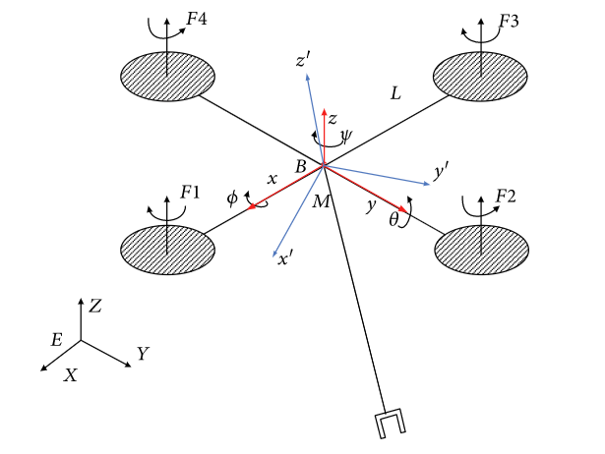

(X, Huang,Y, Zhang, etc, 2017)

## Constraints and Considerations:

## Regulations and Legal considerations

* Drones are not to be flown higher than 120m above ground,
* When flying drones, they should never be 30m closer to people.
* Drones should be flown within eyesight and respect personal privacy.
* Drones weighing more than 250 grams are not to be flown near 5.5KM of airports.
* The time to fly drones is only during the day.

### **Project/Team constraints and considerations**

* Team communication/management
* Timeframe and deadlines
* Resource Availability (software and team documents)

# System modelling

### **Key Elements**

Evidence that the team has made excellent progress towards this design process and has begun to explore the problem in detail. Evidence of high-quality brainstorming

### Derivation

Let's consider that in a drone, "roll," "pitch," and "yaw" respectively represent the forward rolling and rotation of the drone within quadrants. The dynamic control of the drone on the x,y,z axes cause changes in its position through these various dynamic variations.

(1)

Then we can use (1) get this rotation matrix

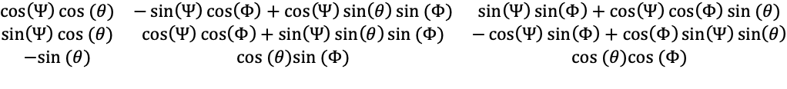

When the UAV is undergoing dynamic control of roll, pitch, or yaw, the effects of the other two axes on the UAV's attitude and position. 

For pitch when the drone is moving forward the other two axes roll and yaw, "I" represents the moment of inertia. It is mainly used to mitigate the effects of the other two axes during the pitch control of the UAV.



Both the angular speed and rotor moment of inertia will have an impact on the UAV's attitude and position during dynamic control.

### Final Equation

The three models in the diagram are based on the control of the quadcopter in three coordinates, where x, y, and z correspond to its dynamic changes in motion when the UAV moves in different quadrants.

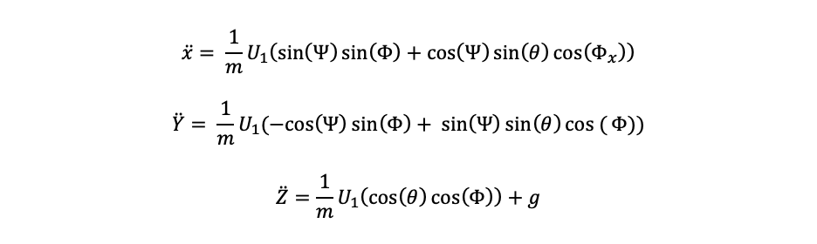

This dynamic control involves the manipulation of the four motors. , , , and correspond to the models for the roll, pitch, and yaw of the UAV, respectively.



U1 represents the control of the UAV along the x-axis, used to control the UAV's take-off and descent. U2 represents the control for the UAV's left-right roll movement. U3 represents the UAV's pitch, which can be used to control the UAV's forward or backward movement. U4 represents the UAV's yaw motion, which refers to the horizontal rotation of the UAV. U1-U4 represent the torque.

# Team Charter

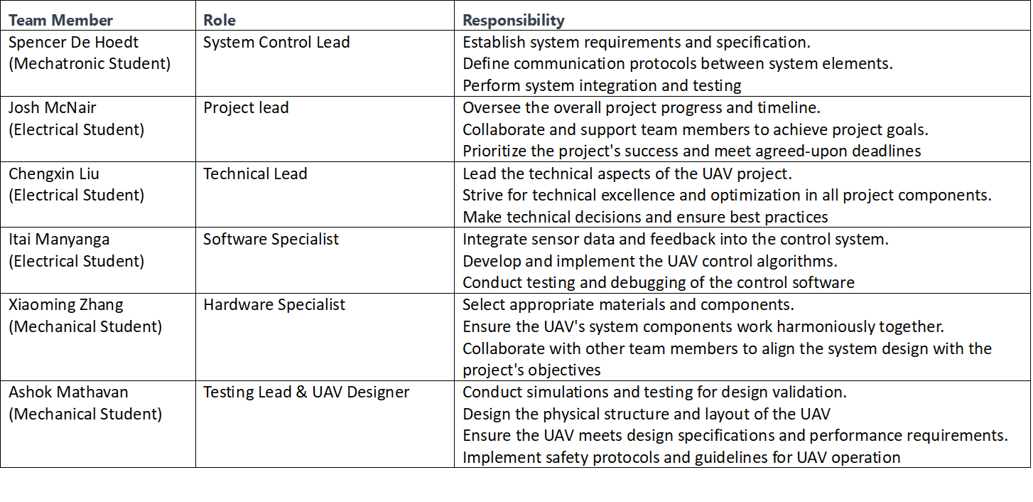

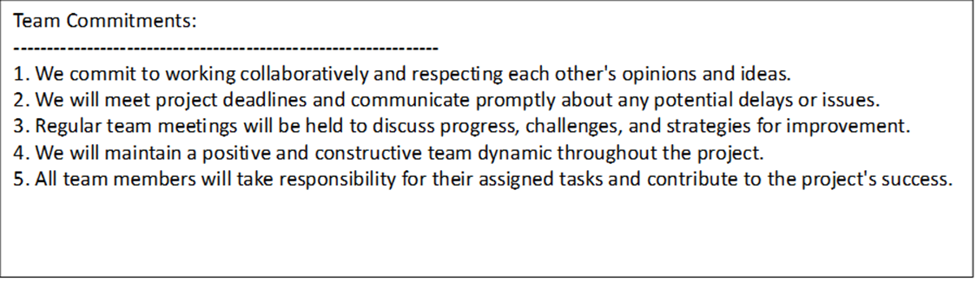

*I certify that I have actively participated in the development and production this Design Brief document.*

|  |  |  |
| --- | --- | --- |
| **Team Member** | **Signature** | **Date** |
| Ashok Mathavan | *M. Ashok* | 02/08/23 |
| Chengxin Liu |  | 5/8/2023 |
| Itai Manyanga | I.M | 01/08/23 |
| Josh McNair | J.M | 3/08/23 |
| Spencer De Hoedt | S.D | 5/08/23 |
| Xiaoming Zhang |  | 31.07.23 |

# References

[1] Lutkevich B. Drone (UAV) [Internet]. 2023. Available from: https://www. techtarget.com/iotagenda/definition/ drone

[2] Koç Mehmet Tuğrul. Drone Technologies and Applications

Submitted: June 4th, 2023, reviewed: June 6th, 2023, Published: June 26th, 2023

<http://dx.doi.org/10.5772/intechopen.1001987>

[3] Drone Simulation and Control, Part 1: Setting Up the Control Problem.

<https://www.youtube.com/watch?v=hGcGPUqB67Q> [YouTube video], 2018.

[4] Mario. Physics Behind How Drones Fly.

<https://www.dronetechplanet.com/physics-behind-how-drones-fly/>, 2021

[5] Rajan Gill and Raaello D'Andrea. Computationally efficient force and moment models for propellers in uav forward flight applications. Drones, 3(4), 2019.

[6] Simulink Support Package for Parrot Minidrones. <https://www.mathworks.com/matlabcentral/fileexchange/> 63318-simulink-support-package-for-parrot-minidrones, 2021.

[7] Noordin A. Basri M.A.M and Mohamed Z. “Simulation and experimental study on PID control of a quadrotor MAV with perturbation,” *Bulletin of Electrical Engineering and Informatics,* vol. 9, No. 5, pp. 1811-1818, October 2020.

<http://dx.doi.org/10.11591/eei.v9i5.2158>

[8] X, Huang,Y, Zhang, etc. (2017). Dynamic Stability and Control of a Manipulating Unmanned Aerial Vehicle. Nanjing University of Information Science & Technology, Nanjing 210044, China. Retrieved from:

[Dynamic Stability and Control of a Manipulating Unmanned Aerial Vehicle (hindawi.com)](https://www.hindawi.com/journals/ijae/2018/3481328/)

# Appendix

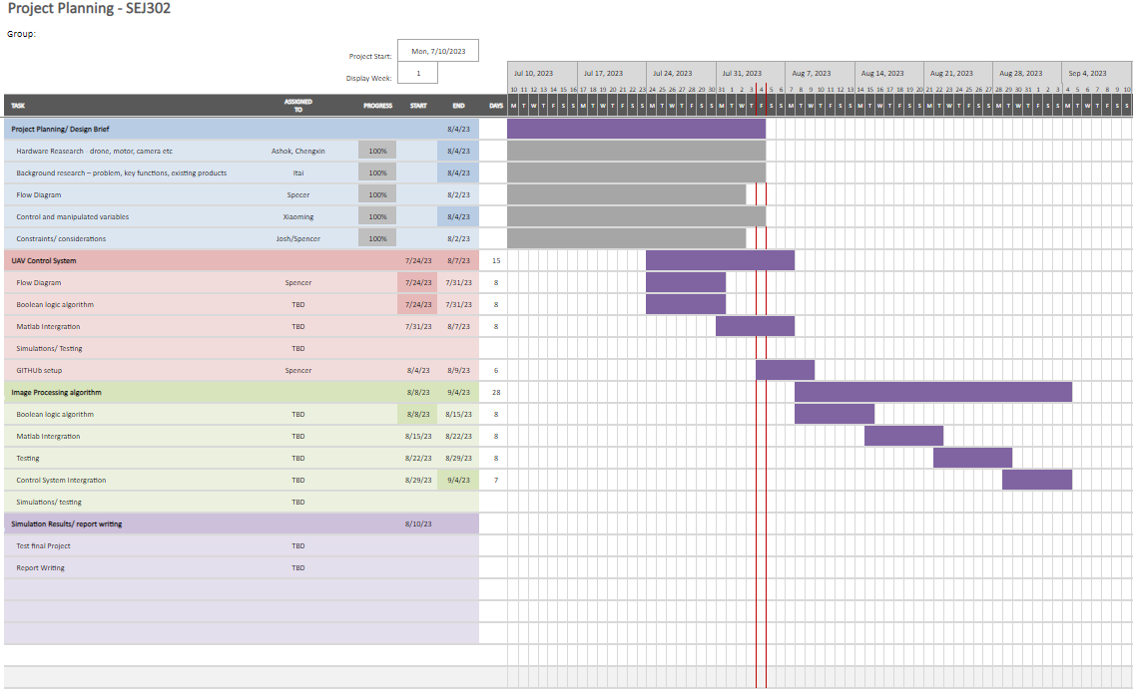

Figure 25 - Gnat Chart